Name: CHALIL DHEERAJ Date: 22-10-2020
Experiment no: 4
Aim
To write a program to draw a line using Mid-Point line drawing algorithm.
Program
import OpenGL
OpenGL.ERROR_ON_COPY = True

from OpenGL.GLUT import *
from OpenGL.GL import *
from OpenGL.GLU import *
w,h = 500,500

def init2D(r,g,b):
glClearColor(r,g,b,0.0)
glMatrixMode (GL_PROJECTION)
gluOrtho2D (0, 500.0, 0, 500.0)

def midPoint(X1,Y1,X2,Y2):
# calculate dx & dy
dx = X2 - X1
dy = Y2 - Y1

# initial value of decision parameter d
d = dy - (dx/2)
x = X1
y = Y1

# Plot initial given point
# putpixel(x,y) can be used to print pixel
# of line in graphics
print(x,",",y,"\n")
# iterate through value of X
i = 0
while (x < X2):
x=x+1
# E or East is chosen
if(d < 0):
d = d + dy

# NE or North East is chosen
else:
d = d + (dy - dx)
y=y+1

X[i] = x
Y[i] = y
i = i + 1

# Plot intermediate points
# putpixel(x,y) is used to print pixel
# of line in graphics

def plotDDA():
glClear(GL_COLOR_BUFFER_BIT)
glPointSize(4.0)
glColor3f(0.0, 1.0, 0.0)
glBegin(GL_POINTS)
for i in range(length):
glVertex2i(X[i],Y[i])
glEnd()
glFlush()

a,b,c,d = [int(a) for a in input("Enter x1 y1 and x2 y2 value: ").split()]
global length
length = (c-a) if (c-a) > (d-b) else (d-b)
X = [0] * length
Y = [0] * length
midPoint(a,b,c,d)
glutInit(sys.argv)
glutInitDisplayMode(GLUT_SINGLE | GLUT_RGB)
glutInitWindowSize(w, h)
glutInitWindowPosition(100,100)
glutCreateWindow(b'Line using Mid-point Algorithm')
init2D(0.0,0.0,0.0)
glutDisplayFunc(plotDDA)
glutMainLoop()

Result
Successfully executed a program to draw a line using Mid-point Line drawing algorithm in python and obtained output using OpenGL library.
Input
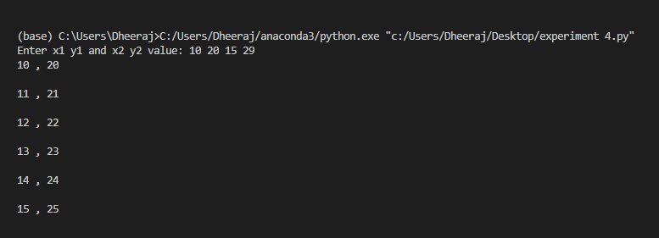
Output
